Audioholics 2008 SOTU Trade Show Event – Schedule of Events
Oct 21 Tuesday Sencore Set-up
Oct 22 Wednesday Sencore Training Day 1 / Manufacturer Setup
Oct 23 Thursday Sencore Training Day 2 / SOTU Day 1 / Banquet Event
Oct 24 Friday SOTU Day 2 / Breakdown

Storage
Date: Event: Time Location
Oct 20 Storage (after 5pm) Europe 11
Oct 21 - 24th Storage 24 hrs Europe 11

Sencore Training
Date: Event: Time Location
Oct 21 Sencore Setup (after 8 am) Australia 2
Oct 22 Sencore Training 8:30am – 6:00pm Australia 2
Oct 23 Sencore Training 8:30am – 5:30pm Australia 2
Oct 24 Sencore Breakdown by 7pm Australia 2

Educational Room
Date: Event: Time Location
Oct 22 Education Setup after 1pm Asia 5
Oct 23 Education Day 1 9am-5pm Asia 5
Oct 24 Education Day 2 9 am – 4pm Asia 5
Oct 24 Education Breakdown 4pm - 5pm Asia 5

Demo Rooms
Date: Event: Time Location
Oct 22 Demo Setup after 1pm Europe 7,8,9
Oct 22: Demo Setup after 1:30pm Europe 4
Oct 22 Demo Setup after 8am Europe 5,6,10
Oct 23 Demo Day 1 10am – 5pm Europe 4-10
Oct 24 Demo Day 2 9am – 3:30pm Europe 4-10
Oct 24 Demo Breakdown 4pm - 11:59pm Europe 4-10
Note: Equipment must be cleared out of all demo rooms before midnight Oct 24th

Social Functions
Date: Event: Time Location
Oct 22 Sponsor Reception 6pm – 8pm Asia 4
Oct 23 Breakfast 8:30am - 9:30am Outside Europe 5
Oct 23 Sponsor Lunch 12pm – 1 pm Asia 4
Oct 23 Children Party 4pm – 11pm Americas Seminar
Oct 23 Appetizers 6:00pm – 7:00pm Southern Foyer
Oct 23 Dinner / Party 7:00pm - 11:30pm Southern I-II
Oct 24 Breakfast 8:30am - 9:30am Outside Europe 5
Oct 24 Sponsor Lunch 12pm – 1pm Asia 4

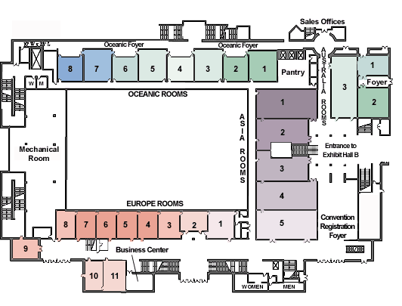

Room Exhibitors
Europe 4 Sherwood Newcastle
*Europe 5 Yamaha / EMP
*Europe 6 Epson
Europe 7 Marantz / Snell
Europe 8 Audyssey
Europe 9 Emotiva
*Europe 10 Dolby/Pioneer
Europe 11 Storage
Asia 4 Sponsor Welcome Reception & Lunches
Asia 5 Educational Seminars

Hotel Contact for event arrangements:
Shauna Callahan - Conference Manager
scallahan@swandolphin.com
P: 407-934-4643 F: 407-934-4355

